The dynamics of the media agenda in Spain:
Comparing the front pages of El Pais and EL Mundo (2000-2009)

Anna Maria Palau
University of Barcelona
apalau@ub.edu

Laura Chaqués Bonafont
Institut Barcelona d’Estudis Internals IBEI
Universitat de Barcelona
laurachaques@ub.edu

Luz Muñoz
luzmunozma@ub.edu
University of Barcelona

-First draft-

X Congreso Español de Ciencia Política y de la Administración
Murcia 7-9 de septiembre de 2011

This paper has two different goals. The first is to compare issue attention on the front pages of the two Spanish leading newspapers from 2000 to 2009, and to identify the similarities and differences in the pattern of prioritization of issues across time (percentage of attention and correlations); to what extend some issues like foreign affairs, war or elections capture most of the media attention like it happens in other countries like the US; whether media attention shifts more or less rapidly from one issue to another (friction); and to what extend there is a similar degree of complexity and fragmentation of the media agenda of both newspapers.
The agenda capacity of the newspapers front pages is by definition extremely limited. As Boydstun (2009) demonstrates for the case of the US some issues such as elections, war and international diplomacy are more commonly featured on the front page than others, a small number of topics often gain very large proportions of the overall attention, and because it has much higher barriers to entry, front page attention tends to stay focused on those topics that were the focus of attention in the previous time period. From here we should expect for the Spanish case that most issues, most of the time have restricted access to media attention, and also that shifts in attention follow the punctuated equilibrium model.
Baumgartner and Jones (1993, 2005) developed the punctuated equilibrium model in order to explain agenda dynamics. According to this model, changes in attention are disproportionately distributed; rather than shifting incrementally, the agenda displays periods of stasis punctuated by dramatic upheaval. The general argument is that the media does not attend to issues in proportion with their severity, nor does it chase real-world changes over time. Instead, the media agenda tends to get stuck in equilibrium, fixed on the same few issues day after day. Issue attention shifts from one issue to another when it is impossible to ignore the information about the issue, altering the previous status quo (Boydstun 2008). Stability can stem from the unwillingness of major power holders to recognize the need for change (cognitive friction) or can be institutionally induced by the designs of political systems (institutional friction). Such cognitive and institutional bottlenecks are faced by all political subsystems with differences in magnitude and in results.
In relation to this, our second goal is to analyze to what extend these patterns of media attention are related to institutional factors. According to Hallin and Mancini (2004) the Spanish media system, as a part of the polarized pluralist model, is highly politicized, with a high level of political parallelism and state interventionism. Politicization has always been high and has not decreased, despite the increasing corporatization of the media markets. The question we ask in this paper is whether important differences exist on the pattern of prioritization of issues between these two newspapers as the Hallin and Mancini model would predict, or by the contrary, the case of Spain is similar to other countries like the US, in which there is a high correlation in issue attention across newspapers. We also ask whether differences in issue attention on the front pages of El País and El Mundo can be related to the politicization of the media in Spain, or/and other factors such as issue type.
The analysis we present here is the first paper of a research project aimed to contribute to the analysis of the media agenda in Spain for the last decades. Specifically, our goal is to identify the patterns of issue prioritization by the media and to identify the relationship between the media, public and political agenda. The analysis of these questions has been increasingly analyzed by political scientists as a means to have a better understanding of the functioning of the Spanish political system and the consolidation of democracy (eg. Bennet 1990, Entman, 2004, Castells 2009, McCombs 2004, Soroka 2002, Walgrave (2007, Baumgartner and Jones 2009, Jones and Baumgartner 2005 among many others). The project seeks to contribute to the analysis of why and how media prioritizes some issues and not others; to what extent the prioritization of issues by the media can be explained by real world indicators; how the media influences public opinion and policy makers, and to explain why the media, public and political agenda follow similar dynamics in some issues but are completely different in others. The analysis of these questions is used to test different hypotheses already developed within the agenda setting theoretical framework.
To do that we have already created a comprehensive and far-reaching dataset about the news covered in the front pages of two of the most relevant Spanish newspapers –El País, and El Mundo— from 2000 to 2009. The development of these databases follows the methodology of the Comparative Agendas Project, a methodology that has already been used by this research team for the creation of databases about the political agenda and public opinion in Spain. The creation of this dataset seeks to contribute to the quantitative measurement of the media agenda; to develop a comparative analysis of the media agenda in relation to other agendas -policy and public opinion agendas-; other countries and across policy issues.
The paper is organized as follows. First we present a general overview of the Spanish media system following Hallin and Mancini (2004) and Manuel Castells (2004). Next we explain the data and methodology. In the third section we describe the main results about the comparison of the frontpages of El Pais and El Mundo. In the final section we present some results about the politicization of these two newspapers, focusing on political corruption scandals. In the last part we summarize some ideas for future research.

El Pais and El Mundo in the Spanish media system
Spain belongs to what Hallin and Mancini (2004) define as the Mediterranean or polarized pluralist model. This means that newspaper circulation is among the lowest in Europe, that newspapers are politicized, and there is a high level of political parallelism that is reflected in the degree of differentiation in terms of political orientations of their readers. Spanish newspapers tend to represent distinct political tendencies taking an advocacy role, and mobilizing their readers to support different causes (like democratic values and ideas during transition to democracy). The most read are national newspapers located in Madrid (El Pais, El Mundo and ABC) although there are other important newspapers at the regional level like La Vanguardia o El Periódico de Catalunya. Contrary to other European countries, there are not tabloid or sensationalist popular newspapers in Spain, although Sports newspapers are among the most read (Marca, As, Sport and El Mundo Deportivo).
From 1975 to 1989 some of the most important newspapers emerged, like El Pais which becomes the most relevant newspaper to present, Diario 16 or El Periodico de Catalunya, adopting (along with existing newspapers like ABC or La Vanguardia) a new commercial strategy towards a more market oriented press that emulated other media models, mainly the liberal model. The goal was to set the principles and values of a democratic media system and also to expand circulation with forms of journalism that combine the old focus on politics with more human interest, graphic presentations and other commercial strategies. As a result newspaper circulation increased in the 1990s, although aggregate levels today are still very far below the EU average.
Democratization of the media system occurs in parallel to a process of increasing political parallelism, and increasing concentration of the media business into two large multimedia conglomerates with strong political alliances: PRISA (El Pais), and Telefónica (El Mundo). El País was created in 1976 by the media group PRISA and keeps a clear connection with the Partido Socialista Obrero Español (PSOE). As Castells points out (2009:255) “the skillful use of media politics was a factor in healing the Socialist win the elections and stay in power for more than 13 years. Felipe González benefited from an efficient political team that put into practice media politics and image making in innovative ways, using inherited media system in which the government had the monopoly of TV, and radio stations, and an indirect influence on the print press”. The socialist government benefits from this control of the media system, postponing for almost a decade the liberalization, decentralization and privatization of the media in order to keep its monopoly power. The first regional TV stations are created in the mid-eighties, but private TV stations (tele 5 and Antena 3) and satellite TV are only developed in the mid- nineties. Jesus de Polanco, director of the Prisa group is an advisor of the socialist government and also controls the main radio station at that moment (la SER), and other magazines and satellite television (Canal +) from the nineties.
In the nineties, a rival media group emerged around Telefónica, a former state telecommunications monopoly that was privatized by the first conservative government of the Partido Popular (PP). This media group was lead by the general director of Telefonica (which is a close personal friend of José Maria Aznar), and included a satellite TV, a TV station (Antena 3), Onda Cero (a radio station), and El Mundo, a newspaper created in 1989 by Pedro J. Ramirez. El Mundo became the “relentless inquisitor” of the PSOE governments and a media mainstay for the conservatives. “The professional quality of the newspaper and its independence vís-à-vis the socialist government while also providing a platform for the left-wing critics of González, made it the second largest newspaper in terms of readership and guaranteed its good business standing. El Mundo became the explicit harbinger of scandal politics and developed an efficient media format” (Castlells 2009:256).
Actually, the Psoe government engaged in careless illegal operations without taking the most elementary precautions. The Filesa case (illegal financing of the PSOE), the Gal episode (the Antitterrorism Liberation Group created to fight ETA terrorism by members of the PSOE government), the approapiation of public fund by JL Roldan the first civilian appointed Director general of the paramilitary police (Guardia Civil, or the tax evasion case of the Governor of the Spanish Central bank (Mariano Rubio) are among the most important scandals and cases of corruption that illustrate the climate of loose morals and personal enrichment of some of the members of the socialist government. Once the PSOE won the elections again in 1993 –against all predictions, in a context of deep economic crisis, and after these major political scandals— several newspapers (El Mundo, but also ABC), private TV (Antena 3) and radio stations (la Cope, owner by the Catholic Church) formalized an alliance by establishing an association of independent Journalist and Writters (AEPI) which attracted all those who wanted to contribute to the demise of González.
The media, and particularly El Mundo, played a major role in diffusing information about government operations, and launched a campaign oriented to uncovered these political and economic scandals, based on the huge existing raw material provided by the PSOE (Castells 2009,Magone 2009, Cabrera and del Rey 2002). This strategy was not only driven by ideological conflicts but also business conflict between media groups. El Mundo, as a new created newspaper wanted to increase audience share by depicting itself as the independent critic of a corrupt government. As a result, El Pais had to echo some of the information about scandals and corruption inside the socialist governments as a means to keep its legitimacy and a share of daily newspapers. In a way, El Mundo was aimed to develop investigative reporting, but it was closely tied to party politics in the sense that the media only revealed scandals about their partisan enemies. Nevertheless it clearly made the media more central as a political actor than in the past (Hallin and Mancini 2004:124).
The role of the media as a new scenario for politics increases in the mid-nineties as elections became increasingly competitive, and mainly when the PP won election in 1996. From 1996, the PRISA group adopted a critical role against governmental activities, and El Mundo with the COPE and Antena 3 became an important ally of the PP Government. The increasing concentration of the media into these two large business groups has not fostered a major change in the characteristics of the Spanish media system towards a more professionalized and autonomous media. The professional organizations and journalist’ unions are still weak , there is not a strong consensus on journalistic standards and a limited development of professional self regulation that reflect that journalism is not an autonomous institution, but has been ruled by external forces, mainly from the worlds of politics (Hallin and Mancini 2004:113, Bustamante 2000, Hallin and Papathanassopoulos 2002:180) Perhaps, one of the interesting differences in relation to other southern countries is that these media conglomerates are not dominated by other industries, but by media groups that keep an advocacy role despite the increasing globalization and liberalization of the media market (Bennet 2004).

The data
The methodology used in this article is aimed to integrate qualitative and quantitative methods in order to give a systematic explanation of media agenda dynamics. To do that we have created a comprehensive and far-reaching databases of the stories covered in the front-pages of two of the most relevant Spanish newspapers (el Pais and El Mundo) from 2000 to 2009 –although our goal is to go back to 1989, the year that El Mundo was created—. This extended time period allow us to identify long-terms trends in media attention. Overall, the database includes 68.298 stories, 35.892 for El País and 32.406 for el Mundo. Front pages stories are important indicators of the prioritization of issues by the media, differing significantly from the rest of the paper since they reflect the issues that editors and journalist consider the most important or striking, and they are also the first thing that people see when reading a newspaper capturing most of the attention of the public in general.
For coding front-pages stories we have considered, among other variables, the title of each story, date of publication, and the area of the headline and photo; the issue code and subcode according to the 23 major topics and 247 subtopics of the Spanish Policy Agendas project (www.ub.edu/spanishpolicyagendas); and also information to identify the most important actors involved, both at the national and international level. Identifying political actors is important because in some cases, individuals, groups or political parties can be linked to certain types of issues (issue ownership). The main variables used to code actors are which parties are mentioned in the story; and who is mentioned (head of state, prime minister in the regional or national level, parliaments, the constitutional court, social movements, etc.). We have also created other variables to analyse whether stories refer to elections (national, regional, local or European) or to morality issues (abortion, same-sex marriage, etc.). As a whole, for each article we have gathered information about 37 different indicators which allow for systematic coding of media agenda.
Each story has been coded for two different coders with a reliability of 93.25 % at the code level and 90.35 at the subcode level. When coding, coders only rely on what is written in the stories, and do not draw on their personal experiences or emotional responses to the story. The creation of a systematic and uniform coding scheme is especially relevant to carry out a comparison of the Spanish case with the rest of countries involved in the analysis of media agendas dynamics. This coding is based on the scheme elaborated by the Comparative Policy Agendas Project, basically led by the Belgian team, directed by S. Walgrave, who has elaborated a specific handbook for the media coding.
To analyze the politicization of media attention we have coded the main political corruption scandals occurred in Spain during the last decade. As table 1 illustrates, we have considered the type of scandal and also the political party involved in the scandal. Overall, there are 17 cases of political corruption, six related to the PSOE (or socialist regional parties), eight to the PP, and two related to the Catalan regional party (CIU). We have also included two generic categories, one for corruption in local authorities and another to cover isolated cases of corruption (“other”) that involve different political parties.

(Table 1 about here)

So similar, so different: the front-pages of El Pais and El Mundo
A general overview of issue attention on the front pages of El Pais and El Mundo suggests that both newspapers share important similarities in terms of agenda capacity, level of friction and concentration of issue attention. By agenda capacity we refer to the number of stories included in media front pages. Both newspapers publish about 362 front pages a year, each one holding about 10 stories for the case of El Pais, and 8 stories for the case of El Mundo. AS figure 1 illustrates, agenda capacity is quite stable across time for both newspapers with a slightly tendency to reduce the number of stories per frontpage.

(Figure 1 about here)

A second characteristic is that the media agenda is quite fragmented across issues, and this is especially the case for El Mundo. To measure issue fragmentation we have calculated Entropy scores for the content of the front pages of both news papers across the major 23 topic codes over time. Entropy, as a measure of the relative concentration or dispersion of data is similar to Herfindahl indices used in other studies of policy agendas and interest group mobilization (e.g. Gray and Lowery, 1993; 1996; 1998 Baumgartner et al., 2000) but it is a more powerful measure for data with low levels of concentration (eg. See Jennings et al. 2011). Entropy score range from 0 to the natural log of 23 (3.1354). An entropy score of 0 indicates that attention is concentrated in a single topic, by the contrary, an entropy score of 3.1354 indicates that attention is perfectly distributed across issues. The higher the entropy score, the less concentration of the media agenda. When plotted over time, this indicates variation in media attention to the range of different topics on the media agenda. As Figure 2 illustrates: (1) the agenda of both newspapers is quite fragmented and this is especially the case for El Mundo, and (2) there is a quite stable trend across the decade with some minor variations towards more fragmentation. This is, issue attention is quite spread across different topics for the whole period, with minor variations at the end of the decade.
(Figure 2 about here)

As figure 3 and table 2 – illustrate, most of the attention is devoted to state basic functions. In order to describe media attention, we have organized the 23 topics into 5 main categories –economic, welfare, environment and energy policy, state basic functions and other issues like sports, culture, natural disasters and death notices which have a quite low level of political content—. State basic functions capture more than 50% of the attention for the whole period, with some variations. Attention to defense (topic 16) and especially to war (1619) is directly driven by the Iraq war and thus especially important from 2002 to 2004; governmental affairs (topic 20) always capture an important share of the attention, and they are mainly connected to elections and political scandals. Crime and justice (topic 12) also captures an important share of the attention, and it relates to stories about terrorism (ETA) and crime. Finally, attention to rights issues is related to immigration, but also to moral issues like abortion, or same sex marriage.

(Table 2 and figure 3 about here)

The percentages of stories related to the economy are important, but never raise more than 23% of the total in the case of El Pais, and 18% in the case of El Mundo. Attention to welfare issues is even lower (less than 10% for both newspapers, especially in the mid-2000 when attention goes down to 5%) and the same occurs for welfare issues (always below 5% with the exception of 2006, capturing 7%of the stories in El País). In general, attention to state basic functions is steady across the decade while attention to other issues fluctuates more depending on the political, economic and social context. In a way this indicates that issues related to Government, foreign affairs, crime and justice, defense, and rights have a quite fixed space in the agenda, while the rest of issues compete more for getting some space in the frontpages of these two newspapers. Again this opens the question about agenda capacity and competition across issues, and which factors determine the capacity of some issues to get into the media agenda at different points of time.
The analysis at the subtopic level illustrates that one third of the stories on the front pages of El País and El Mundo are about ten issues, all of them related to state basic functions (or high politics) with the exception of the evolution of the Stock market (subtopic 1502). Table 3 summarizes this information. Perhaps what it is even more interesting is that the top ten issues are almost identical for both newspapers with the exception of the Stock market that is among the ten most important of El Pais, but only appears among the twenty most important in the case of El Mundo. In general, El Mundo pays more attention to terrorism, crime, political parties, scandals of corruption, and national-regional government relations, while El Pais pays more attention to foreign affairs (diplomacy), immigration, elections and the stock market. Differences also exist on the percentage of stories about culture (always much more important in El pais) and Sports (always more important for the case of El Mundo).

(table 3 about here)

These top 10 issues are also the issues that capture most of the attention of the Presidente del gobierno while giving the annual speech, and also are among the issues that most Spaniards identify as the most important problem facing the nation in the 2000 (Chaqués and Palau 2011, chaques et al 2008). Immigration or terrorism is always a priority issue for both public opinion and the government. By the contrary, those issues related to foreign policy and diplomacy are never mentioned by public opinion as especially relevant. In any case, these first results suggest an important connection between the media agenda, public opinion and the political agenda that we will investigate in further detail in the future.

Issue correspondence
One way to go further in the analysis of the similarities and differences on issue attention is by analyzing monthly annual correlations of the percentatge of attention between newspapers. As a whole, percentage correlations are very high at the annual (0.957) and monthly bases (0.89) with no differences across time (figure 4 and 5). But, as illustrated in table 1 there are important differences across issues. First, in the case of governmental issues (topic 20), defense (topic 16), the economy (topic 1) and agriculture (topic 4), social issues (topic 13), the environment (topic 7) and energy policy (topic 8) annual correlations are quite high and significant. Second, , there are some topics (health and public lands, which basically refers to water policy for the case of Spain) that are only moderately correlated; and finally, there are some issues with a low or even negative correlation like transportation, research and development, foreign trade, education, labor, housing, natural disasters, sports or culture.

(figure 4 and 5 about here)

Figure 6 gives information about monthly correlations of the percentage of attention at the subtopic level for the issues included in the top ten list (table 3). Results are summarized in figure 6. The first conclusion is that there are important variations across subtopics. In the case of war, elections, political parties and issues related to intergovernmental relations (national versus regional governments or Comunidades Autónomas) correlation is very high –newspapers pay a lot of attention to these issues quite at the same time—. By the contrary, for other issues like crime and immigration, both newspapers seem to pay a similar level of attention, but with important differences across time (monthly correlations are .371 and .426 respectively). Finally for issues like sports and culture the explanation could be more directly attributed to the editorial line of the newspaper. In general El País pays much more attention to culture than el Mundo, while the opposite occurs in the case of Sports.
From here, the goal is to explain why these differences occur, and whether they are related to issue type. At first glance, we can say that in some cases, like agriculture –that capture a quite small share of attention on the front pages of both newspapers (0.8% El País and 0,5% for El Mundo— attention is driven by external factors or crisis situations beyond control of governmental actors or other institutions, like the mad cow scandal (correlation of the percentage of attention for agriculture is .921). The same argument could be used for explaining attention to issues like the environment (which could be linked to the oil-split of the Prestige for example) or energy policy. Only 1,5% of the stories on the front pages of both newspapers are related to these issues, but correlation is extremely high (.772 and 0.865 respectively).
In other cases, high correlations are more related to endogenous factors. As Vliegenthart and Walgrave (2008) emphasize some issues capture the attention of the media in a quite predictable way, following routines quite connected to government operations and electoral campaigns. One way to look at this argument is to test whether issue attention is more similar during electoral campaigns. To analyze to what extent elections make a differences in the front pages of El Mundo and El País, we have calculated the monthly correlation between the stories that refer to elections -we have used a dummy variable, with value 1 if the story refers to elections (general, regional, local and European elections) and 0 otherwise—. We have also used a dummy to discriminate between elections with domestic impact and elections in other countries. As figures – and - illustrate, our results give support to this argument. Overall, media attention mostly follows the election cycle: attention to elections increases when general elections are approaching (2000, 2004 and 2008) and start to decrease just after elections, reaching the lowest percentage of attention two years after elections. By the same token, the monthly correlation between the percentage of stories that refer to elections is higher (0.82) than the monthly correlation between stories that are not related to elections (0.55 always significant). Correlation is also higher for stories that refer to national elections (0.8) than for stories that refer to elections in other countries (0.6).

(figure 6 and 7 about here)
Friction
Finally, we compare friction of front-page news coverage for both newspapers. To do that we measured kurtosis and run a standard statistical test, the Kolmogorov-Smirnov test, in order to evaluate whether changes in media attention in the front-pages of El País and El Mundo are incremental or punctuated. To do that we have calculated two distributions based on monthly percentage changes, that is, for each newspaper we have calculated the percentage change in attention to a given topic from month to month over the total period of study. Kurtosis has been already been employed by other authors like Wolfe, Boydstun and Baumgartner (2009) to compare topics of front-pages and full-paper stories in the New York Times, or to more generally analyze policy dynamics across time and different agendas like budgeting (Baumgartner et al. 2010, Jones and Breunig 2007). Kurtosis is a measure to describe the general shape of a distribution in terms of flatness or peaked. In case of high kurtosis (or leptokurtosis) distributions have high central peaks and fat tails compared to a normal distribution, while the contrary occurs for flats distributions of platykurtosis.

(Figure 8 and 9 about here )

Friction is high when there is a high kurtosis, and the distribution has a high central peak and fat tails. This indicates that in general we should expect that tomorrow’s attention should be quite similar than today’s, and this tendency is only interrupted occasionally by alarmed discovery of new topics that urgently demand more attention (Jones and Baumgartner 2005). Our results indicate that issue attention for both El Pais and El Mundo follow a distribution that is not normal. They are leptokurtic, with a kurtosis of 10.76 in the case of El País and 9.60 in the case of El Mundo. The Kolmogorov-Smirnov test, based on the null hypothesis that the underlying probability distribution is normal, is rejected for both distributions (K-S is 5.48 in the case of El País and 6.32 for el El Mundo and significance is < 0.05 in both cases), which corroborated that changes in attention are not incremental. Because of the high barriers of entry associated to the front pages, new issues only get into the media agenda occasionally, following a sudden change.

Politicization of the media: the coverage of political corruption scandals
To measure the politicization of media attention we have analyzed the coverage of Spanish political corruption scandals by El Mundo and El País, from 2000 to 2009. According to Hallin and Mancini (2004) we should expect that the front-pages of these two newspapers present some differences in the coverage of scandals because as explained above, both newspapers present a direct link with a party ideology and have played an important role as allies or opponents of the governing party. The role of the media in this type of scandals is especially relevant as events concerning political corruption fall into the category of unobtrusive issues, that is, the media is the main source of information available to most citizens (McCombs, 2004). As a result, the media have an important role to play as watchdogs, informing citizens (or not) about the conduct of those in power (Puglisi and Snyder 2008).
Figure 7 summarizes attention to political corruption scandals from 2000 to 2009. It gives information about the overall level of attention to this issue considering the number of stories per month in both news papers. We observe that there are similarities regarding issue attention–in both newspapers there are five mean peaks of attention— but overall El Mundo gives more coverage to political corruption scandals than El País. El Mundo devotes 3.04% of their front pages to cover political scandals and El País only 2.26%. If we consider the type of scandal, as expected, El País gives more coverage to political corruption scandals in which the PP is involved (52% of stories on political corruption in El País refer to scandals related to the PP while in El Mundo represent only 31%); and El Mundo pays more attention to scandals in which the PSOE is involved (24% of stories on political corruption in El Mundo refer to the PSOE while in El País represent only 5%) (figures 8 and 9). The analysis of monthly coverage corroborates that both newspapers do not cover all political scandals with the same intensity, irrespective of the political orientation of the political party involved. Over time El País pays more attention to scandals in which the PP is involved and the opposite, El Mundo gives more coverage to scandals related to the PSOE (figures 10 and 11).
To further analyse whether there are difference between both newspapers in the coverage of political scandals we have compared two scandals, one related to the PSOE – the GAL— and one related to the PP –Gescartera—. The GAL (Antiterrorist Liberation Groups) were death squads created illegally by officials of the socialist government between 1983 and 1987 to fight ETA (the Basque terrorist group). The scandal was initially investigated in 1987 but trials last until 2011. Gescartera is a financial scandal occurred in 2001 in which several members of the PP, among other institutions, were involved. As figure 12 illustrates attention to the GAL is always higher in El Mundo, and particularly in 2004, when the possibility that the new elected president, Rodriguez Zapatero, passes a petition of clemency for Rafael Vera, one of the key players in the GAL affair, is discussed. Overall, in 2004 el Mundo devotes 51% of the front pages on political corruption to the GAL affair while El País only 14% (table 4). One year later, in 2005, El Mundo still devotes 32% of corruption stories to this issue while in El País is almost out of the agenda (4%). Similarly in the case of Gescartera, attention is always higher in El País (figure 13). In 2001 when the scandal came to light, El País devotes 51% of the total stories on political corruption to this scandal while El Mundo only 38% (table 4). In 2002, el País still devotes 40% of their front pages on political scandals to Gescartera while in El Mundo represent only 9.8%.

Some final remarks
At this point we can arrive to the conclusion that the stories appearing in the front pages of El País and El Mundo deal with quite similar issues. Issue correspondence is quite high although important differences in the level of attention exist across policy issues. Variations in issue attention suggest that in some cases the capacity of a new issue to get into the media agenda is linked to exogenous factors, like in the case of agriculture or the environment, while in other cases the capacity of an issue to get into the front-page is more related to endogenous factors like elections. In any case, results also indicate that because of the limited agenda capacity of the front-pages, there are important barriers of entry, and to get attention in the front-pages of both newspapers is a quite difficult tasks. Friction is high and changes on issue attention seem to corroborate the punctuation equilibrium model.
From here our goal is to go further in the analysis and to better comprehend the dynamics of the media agenda both at the theoretical level, but also methodological level. This means to analyze the connection between the political agenda, public opinion and the media agenda following the work of the Comparative agendas project, and the work we have already done to explain the political agenda in Spain; but also to test the existing conceptual models for the case of Spain, from indexing theory (Bennet, Entman) to the punctuated equilibrium (Baumgartner and Jones 2009, Jones and Baumgartner 2005, Walgrave et al 2009, Soroka 2004), in order to see whether they are useful tools to explain the Spanish media system and/or the dynamics of the media agenda in Spain.
Besides, the results presented here also suggest that we should expand our research to better capture differences in the degree of politicization of issues. The analysis of political scandals along the last decade clearly illustrates, as Hallin and Mancini (2004) argue, a political bias in both newspapers. El Pais and El Mundo pay a lot of attention to political corruption scandals with important differences about the type of scandal they talk about. In this paper we have analyzed the politicization of the media in Spain considering the type of scandal and the political party involved in the scandal, but aaccording to the framing literature, if we analyse how both newspaper frame the stories (and the tone) we will probably find further differences in the coverage of scandals. To do this it is necessary to include other variables going further in the construction of our databases. This is something we will do in the near future. Our goal is to systematically analyze the tone of each story and to go further on the analysis of framing in order to have a more complete explanation about how issues are framed, and also to what extend different frames reflect the degree of politicization and distribution of power in the Spanish political system.

References
Arsenault, A. H. Castells, M. (2006). “Conquering the minds, conquering Iraq”. Information, Communication & Society 9 (3): 284-307
Baumgartner, Frank, and Bryan Jones. (2009). Agendas and Instability in American Politics, Chicago: Chicago university Press
Bennett, W. L. (2004). “Global Media and Politics: Transnational Communication Regimes and Civic Cultures”. Annual Review of Political Science 7: 125-148
Boydstun, A. E. Glazier, R. A. (2011). “The Crisis Framing Cycle”. Under review
Boydstun, A. (2008 and forthcoming). How issues become front-pages. Phd Dissertation
Cabrera, M. Del Rey, F. (2002). El poder de los empresarios. Madrid: Taurus
Castells, M. (2009). Communication power, Oxford: Oxford University Press.
Chong, D. Druckman, J. N. (2007). “Framing Theory”. Annual Review of Political Science 10: 103-126.
Chaqués Bonafont, Laura and Anna M. Palau. (2011). “Are Spanish Policy makers responding to citizens?”, West European Politics, 34:4
Entman, R.M. (2004). Projections of Power. Framing News, Public Opinion, and U.S. Foreign Policy. The University of Chicago Press: Chicago
Gunther, R. Montero, J.R. Wert, J.I. (1999). “The Media and Politics in Spain: from Dictatorship to Democracy”. Institut de Ciències Polítiques i Socials WP 176
Hallin, D. C. Mancini. P. (2004). Comparing Media Systems. Three Models of Media and Politics. Cambridge University Press: New York
Hallin, D. C. Papathanassopoulos, S. (2002). “Political clientelism and the media: southern Europe and Latin America in comparative perspective”. Media Culture Society 24 (2): 175-195
Jennings, S. Bevan, A. Timmermans, G. Breeman, S. Brouard, L. Chaques, C. Green-Pedersen, P. John, P. B. Mortensen, A. M. Palau. (2011). “Effects of the Core Functions of Government on the Diversity of Executive Agendas”, Comparative Political Studies (Special Issue)
Jones, Bryan, and Frank Baumgartner. (2005). The Politics of Attention, Chicago: Chicago University Press.
Magone, J.M. (2009). Contemporary Spanish Politics. Second Edition. New York: Routledge
Mccombs, M. Zhu, J-H. (1995). “Capacity, Diversity, and Volatility of the Public Agenda: Trends from 1954 to 1994”. The Public Opinion Quarterly 59 (4): 495-525
Nisbet, M. C. Brossard, D. Kroepsch, A. (2003). “Framing Science: The Stem Cell Controversy in an Age of Press/Politics”. The International Journal of Press/Politics 8 (2): 36-70
Vliegenthart, R. Walgrave, S. (2008). “The Contingency of Intermedia Agenda Setting: A Longitudinal Study in Belgium”, Journalism & Mass Communication Quarterly 85 (4): 860-877
Wolfe, M. Boydstun, A. E. Baumgartner, F.R. (2009). “Comparing the Topics of Front-Page and Full-Paper Stories in the New York Times”. Paper presented at the Annual Meeting of the Midwest Political Science Association. Chicago, IL, April 2–5, 2009
Yoon, J. Boydstun, A. E. (2011). “Dominating the News: Government Officials in the Front-Page News Coverage of Public Affairs of the United States and Korea”. Working draft, prepared for presentation at the Annual Meeting of the Midwest Political Science Association. Chicago, IL, March 31 – April 3, 2011
Tables and figures

Table 1. Main cases of political corruption scandals in Spain
(2000-2009)

Code | Scandal | Media time window | Political Party involved
1 | GAL | 2000-2009 | PSOE
2 | Caso Aycart | 2000 | PP
3 | Caso Pretoria | 2009 | CIU-PSC
4 | Admin. Hacienda Cataluña | 2000-2002 | PSOE (PSC)
5 | Ercros | 2000-2004 | PP
6 | Marbella | 2000-2009 | GIL
7 | Caso Pallerols | 2000-2009 | CIU
8 | Espionaje Comunidad de Madrid | 2000-2009 | PP
9 | Gescartera | 2000-2008 | PP
10 | Other | 2000-2009 | Different parties
11 | Junta de Andalucía | 2001-2009 | PSOE (PSA)
12 | Financiación PP valenciano | 2000-2009 | PP
14 | Corrupción de Matas | 2001-2009 | PP
15 | Local authorities corruption | 2000-2009 | Different parties
16 | Caso Trabajo | 2000-2007 | PP
17 | Caso Bermejo | 2008-2009 | PSOE
18 | Caso Alvarez Cascos | 2004 | PP
19 | Caso Saiz (CNI) | 2009 | PSOE

Table 2. Annual correlations across issue areas
 | Correlations | % El Pais | % El Mundo
Economic, R+D and Industrial Policy
Economy | 946** | 3,60450563 | 2,89662831
Agriculture | 921** | 0,81212627 | 0,54600981
Transport | 344 | 2,77569184 | 2,28275288
Industry | 525 | 4,13850647 | 3,6493198
Research and Development | 550 | 3,25128633 | 2,77015146
Foreign trade | -199 | 0,64246975 | 0,47197458
total |  | 17,13252677 | 14,15306783
Welfare State
Health | 707* | 3,65456821 | 3,39945091
Education | 483 | 3,26241135 | 3,09097079
Social issues | 674** | 0,83993881 | 0,65089305
Labour | 141 | 1,90794048 | 1,53623099
Housing | 269 | 1,25990822 | 0,62929944
total |  | 9,016826589 | 7,770614184
Environment
Environment | 772** | 1,47684606 | 1,07968041
Energy | 865** | 1,92184675 | 1,74291267
Public Lands | 739* | 0,36156306 | 0,16966407
natural disasters | 456 | 0,81212627 | 0,57068822
total |  | 4,572382144 | 3,562945368
State Basic functions
Rights | 315 | 7,47601168 | 6,97165068
Law and Justice | 931** | 15,6473369 | 20,6465743
defense | 820** | 7,38701154 | 6,35160564
Foreign Affairs | 627 | 5,30385204 | 4,26319524
Government | 944** | 15,9727437 | 18,9067465
total |  | 51,78695592 | 57,13977234
Other
cultural events | 464 | 10,749548 | 8,74541136
sports | -0,024 | 5,58475873 | 7,41586205
death notices | 500 | 1,15700181 | 1,21232687
total |  | 17,49130858 | 17,37360027
total | 957** | 100 | 100

Table 3. Media attention by subtopic
Monthly |  |  | % of attention
correlation | Subtopic | Description | El Mundo | El País
.646** | 1260 | Terrorism | 11,03 | 7,52
.847** | 1619 | War | 3,77 | 3,59
.747** | 2060 | Political parties | 3,18 | 1,34
.635** | 2007 | Political Scandals | 3,04 | 2,26
.751** | 2012 | Elections and political campaigns | 2,74 | 3,49
 | 2099 | Other governmental issues | 2,46 | 2,08
.840** | 2070 | Government-Regional relations | 1,96 | 1,48
.626** | 1929 | Diplomacy | 1,68 | 2,13
.426** | 230 | Immigration | 1,63 | 2,04
.528** | 1202 | Organized crime | 1,59 | 1,36
 | 1502 | Stock market | 1,00 | 1,37
Note: For the case of El Pais, stories about the Stock market are the 9th most important, occupying the 16th in El Mundo.

Table 4. Percentage of stories devoted to the GAL and Gescartera (% on the total stories on political corruption per year)

 | GAL |  | Gescartera
 | El Pais | El Mundo | El Pais | El Mundo
2000 | 17 | 42 | 0 | 4
2001 | 10 | 28 | 51 | 38
2002 | 12 | 37 | 40 | 9
2003 | 0 | 6 | 12 | 0
2004 | 14 | 51 | 3 | 1
2005 | 5 | 33 | 2 | 0
2006 | 0 | 17 | 0 | 0
2007 | 0 | 16 | 5 | 3
2008 | 0 | 2 | 3 | 0
2009 | 1 | 1 | 0 | 0
Figure 1 – Number of stories per year 2000-2009

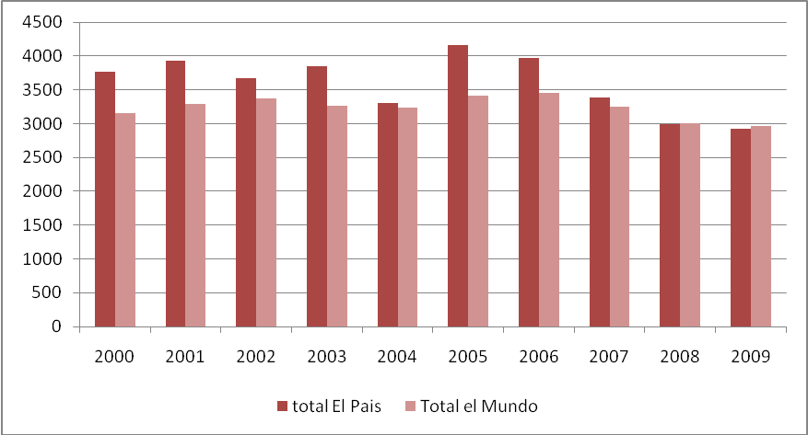

Figure 2- Entropy Scores

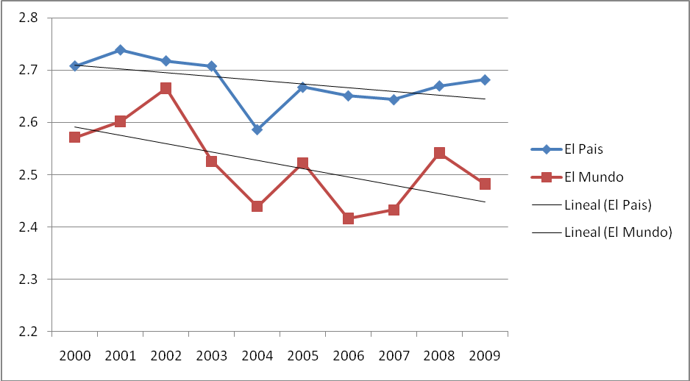

Figure 3 –Percentage of stories per topic (2000-2009)

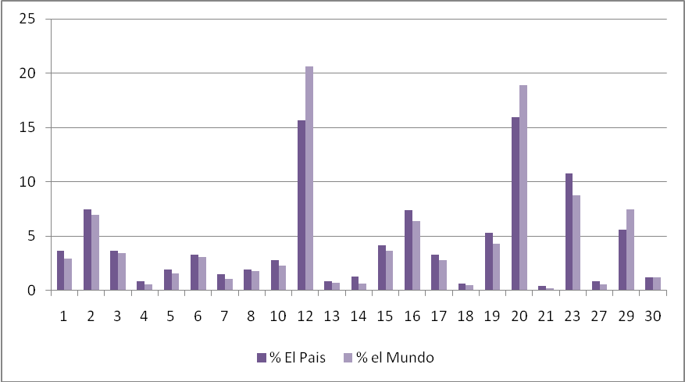

Figure 4 – Annual correlations: El País and El Mundo 2000-2009

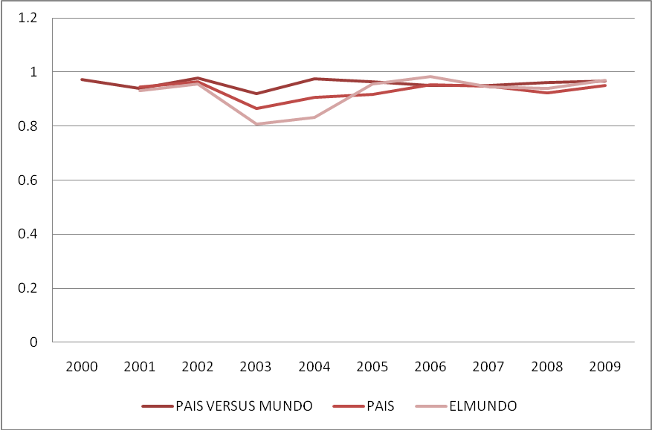

Figure 5– Monthly correlation: El Pais and El Mundo, 2000-2009

Figure 6– Correlation by subtopic: El Mundo and El Pais (2000-2009)

Figure 7– Media attention to political corruption scandals: number of stories per month

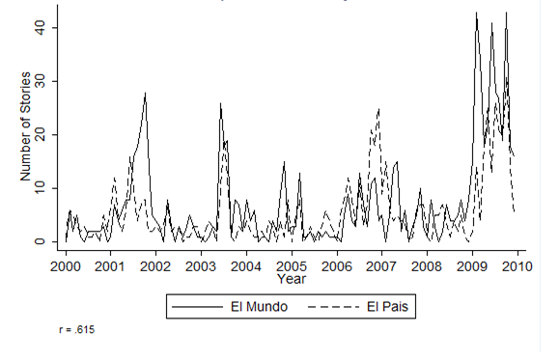

Figure 8. Political corruption scandals in which the PP is involved: number of stories per month by type of scandal

Figure 9. Political corruption scandals in which the PSOE is involved: number of stories per month by type of scandal.

Figure 10. Monthly coverage of political corruption scandals in which the PSOE is involved (number of stories per month)

Figure 11. Monthly coverage of political corruption scandals in which the PP is involved (number of stories per month)

Figure 12. Attention to the GAL scandal (number of stories per month)

Figure 13. Attention to the Gescartera scandal (number of stories per month)

NOTES

We would like to thank the collaboration of the rest of members of the Spanish policy agendas project Luz Muñoz, Ferran Davesa, Lluis Medir and Mariel Julio for the elaboration of this paper. The research for this paper is an output of the project The Politics of attention: West European politics in times of change: the case of Spain (EUROCORES programme), European Science Foundation (ESF), and Agaur (SGR 536).
Entropy scores are calculated as: where the entropy score is estimated as the sum for all topics of the likelihood, p(x), that media attention falls within a particular topic i, multiplied by the natural log of that likelihood, multiplied by minus one

