Winning the centre without moving towards the centre:
Integrating ideological proximity and valence competition

Toni Rodon
toni.rodon@upf.edu

Javier Astudillo
javier.astudillo@upf.edu

*Artículo preparado para el X Congreso Español de Ciencia Política y de la Administración, Murcia 7-9 septiembre 2011.

According to the classical spatial approach to party competition (Downs 1957), parties gravitate towards the median voter in order to win the elections. However, recent research suggests that parties compete on valence issues when they have converged ideologically, a situation in which ideology ceases to be important. This paper proposes a theoretical account which integrates these approaches -the Downsean and the valence debate-, showing that valence dimensions are also employed in a non-centripetal scenario. Our findings suggest that valence issues become more important when the party far away from the centre –the ‘loser’ on the ideological dimension- wins the elections. By doing that, this party is able to win the centre without moving to the centre. Our findings have important implications for party policy strategies and for our understanding of proximity and valence models.
Key words: Ideology, valence issues, party competition, spatial models, Spain.

Introduction
According to the classical spatial approach to party competition (Downs 1957), parties gravitate towards the median voter in order to win the elections. The Downsian model predicts that in a two-party system, when preferences are normally distributed, parties have incentives to satisfy the preferences of the centre voter and thus win this “king-maker” to form an electoral majority.
Notwithstanding the capacity of these classical assumptions to explain vote choice, this model has not been uncontested. Riker (1986) -among others (Berelson, Lazarsfeld, and McPhee 1954; Kinder and Iyengar 1989; Simon 2002; Lenz 2009)- advocated that parties are able to modify the terms in which party competition is based and Stokes (1963) famously dictated that parties can do it by competing on ‘valence’ accounts and thus creating a favourable environment for their electoral prospects.
When do parties emphasise valence dimensions in order to win citizens' preferences? According to a line of thought (Clarke et al. 2004; Green 2007; Green and Hobolt 2008), when policy distances between parties are modest, it is expected valence considerations to be relatively more important to a voter's utility than the ideological distance between the voter and the party. That is, when parties offer similar ideological alternatives, the Downsian model is unable to explain vote choice because parties will tend to compete on valence accounts. This view predicts that if there is an important similarity between the main parties on the left-right dimension, parties will give importance to valence issues in order to convince the electorate.
Contrary to this expectation -focused mainly on British politics (Judith Bara and Budge 2001; Curtice 2005; Judith L. Bara 2006)-, in this article we argue that the emphasis on valence issues is even used when there is no convergence on the ideological dimension. We show by analysing the Spanish case that valence considerations are also important when one party is conspicuously far away from the median voter, turning this party into a 'permanent loser' on the ideological dimension. Our argument is that the party loser will emphasise valence issues as an 'heresthetical strategy' in order to make ideological positions irrelevant for voters. If voters no longer base their vote on ideological considerations, the 'permanent loser' on this dimension will have more chances to win electoral support.
Therefore, this paper contributes to our understanding of how parties that are ‘permanent losers’ on the ideological left-right dimension are able to drive citizens’ preferences to win an electoral majority. The contribution of our analysis is twofold: First, we complement the combination between spatial and valence debate by analysing the Spanish case, a scenario in which an ideological convergence has not taken place and therefore the theory would have predicted the prevalence of the spatial approach (Clarke et al. 2004). We show that even when there is no convergence, the party 'loser' in positional terms promotes a political competition based on valence dynamics, whereas the ‘winner’ emphasises its proximity advantage. Second, we review the relative importance of both issues by analysing how and when this party is able to win the centre voter, a key actor to win the electoral contest. We show that a ‘party loser’ on the ideological dimension is able to attract centre voters by raising valence issues and without following a centripetal strategy. You can win the centrist vote without moving towards the centre of the left-right axis.
Therefore, although several studies have explored how parties compete on valence and positional accounts (Groseclose 2001; Schofield 2003; Schofield and Sened 2005; Green 2007), both have generally been treated as incompatible and very little research has investigated whether the combination between valence and positional party competition is consistent with voting behaviour. In this paper we develop and test a model that combines party theories with voting behaviour which ultimately provide a more comprehensive understanding of both.
The paper is structured as follows: The first part of the paper review the literature on positional and valence models and identify what the literature says about parties consistently damaged on the ideological dimension. Contrary to previous findings, we show that the emphasis on valence accounts is also a way for “permanent losers” to obtain the majority of the key centre voters. Next, we explain how the Spanish case is suitable to illustrate the combination of the positional and valence explanations, showing that without convergence on the ideological scale, the party away from the centre needs to emphasise other issues in which it might have an advantage. Thereafter, we outlined the research designed and we test our predictions with data from sample surveys in the run-up to the 2000 and 2008 Spanish elections. Finally, the conclusion assesses the implications of our findings for the party losers’ literature and draws out the broader implications for studying party competition.

Party loser strategies

Downs’ spatial model (1957) has acquired widespread popularity thanks to its parsimonious capacity to explain how party and voters behave, as well as what strategy parties need to employ to win the elections, and even the emergence of new parties (Stokes 1963, 369). According to this model voters evaluate parties based on the proximity of their policy platforms to voters’ ideal point within a distribution of policy alternatives and choose the party offering a platform that is the closest to that point. Thus, this approach dictates that on this “space” of policy alternatives voters’ utility of voting for a party declines with the distance between voters’ policy preference and parties policy position. As a result, when the median voter is located in the centre of the policy distribution, and only two parties campaign to win the elections, offering a policy platform that is in the centre ground is crucial for parties to obtain their electoral majority. Any party located further away from the centre ground will have fewer chances of winning the elections.
As often underlined, this model is based on several assumptions. Firstly, it is assumed that parties as well as voters are rational and goal-oriented actors that aim at maximizing their preferences (policies in the case of voters, winning the elections in the case of parties).
Secondly, alternatives of government action on which political conflict is focused can be ordered in a one-dimensional policy space. Although not a necessary requisite of Downs’ theory, that dimension is usually considered to be the Left-Right divide. This dimension has been found to be the most common one across European countries (Dalton, Flanagan, and Beck 1984; Franklin, Mackie, and Valen 1992; Eijk 2005). Empirical studies have shown that most citizens living in democratic societies are able to place themselves, and locate political parties on the left-right dimension, and vote accordingly (Knutsen 1997; Eijk 2005).
Thirdly that dimension structuring the political conflict is exogenous to party competition. Parties cannot choose what dimension they compete on. This is given. Forth, individual’s position on the left-right dimension is also exogenous to party activities. Parties are not able to substantially change citizens’ ideological orientations (Adams et al. 2004; Ezrow 2010; Adams, Ezrow, and Somer‐Topcu 2011).
Finally, when a party changes its policy position on this dimension, voters will do believe this movement and will change accordingly their party preference if this movement ends up producing a higher utility for them relative to the utility generated by the other party. Otherwise, Downs’ model would be of little help to advise parties what to do in order to win the elections.
However, many of these assumptions have been questioned, both theoretically and empirically. The very first assumption, voters’ rationality, has been criticised by the so-called Michigan model, which stated that Party Identification (ID) is the crucial element driving vote choice (Campbell 1960; Frode et al. 2005). Many voters do not choose parties depending on their policy preferences. Many voters support, or at least evaluate, policies depending on their party identification (Maravall 2008).
The assumption that political conflict is always structured around one ordered set of alternatives of government action that parties may advocate (such as degrees of government intervention in the economy, or the extent of social expending) has also been put into question. A long time ago, Stokes (1963) pointed out that those issues that a party can exploit for its own benefit are different in nature. He differentiated between two kinds of issues that are present in the public debate: valence and position issues. Valence issues are defined as those issues where both voters and parties agree on the same goals (i.e. economic growth, fight against corruption...), whereas position issues are those on which parties and voters take different points of view (abortion, tax policies, etc.). As argued, valence issues are not distributed in a linear dimension, so if voters regard them as salient, the party who “owns” them has a greater advantage (Blomqvist and Green-Pedersen 2004; Bélanger and Meguid 2008; Green-Pedersen and Mortensen 2010; Abney et al. 2011).
The third assumption, the dimension parties compete on is given, has also been questioned by scholars such as Stokes (1963) and Riker (Riker 1986). When parties are further away than their rivals from the centre of a dimension political conflict takes place on, instead of moving their policy platforms towards the centre as the classical downsian model would predict, they can attempt to increase the salience voters give to an issue in which they previously knew most voters agreed with them. Thus, Riker theorised that opposition parties will continually attempt “heresthetical” moves to introduce new dimensions of partisan conflict. By introducing or emphasising new issues in which parties have an advantage, parties seek exploit them to have an electoral advantage.
When do parties will choose a heresthetical strategy instead of a centripetal one? If it turns out that the last assumption we have reviewed from Downs’ model is not true, and voters usually do not believe centripetal moves by parties as Adams et al. (2011) have empirically shown, this situation transforms the party in a 'permanent loser' in the dimension politics is played. In this case, these parties may prefer a modification of the actual party competition configuration –in spite of its uncertain benefits and its certain costs- to sure defeat.
Taking into account some of these criticisms, some scholars have tried to offer alternative voting models -such as the directional model (Rabinowitz and Macdonald 1989). However, these other models do not have the leverage power of the spatial one. More recently some authors consider that these objections can be integrated into the spatial approach (Merrill and Grofman 1999). McDonald and Rabinowitz (1998), Clarke (2004), Green (2007) and Green and Hobolt (2008) argue that spatial dynamics and valence considerations depend upon the ideological distance between parties. They argue that when parties offer similar alternatives on the common left-right dimension, since voters will not be able to distinguish them, parties have “no alternative” other than competing on valence issues. This means that when parties are very similar in positional terms, valence dimensions will be more important to a voters’ utility and for their party choice than Left-Right ideology, whereas it is expected that the latter will matter more when parties are polarised. As a result, where parties agree on left-right considerations, valence strategies should have particular traction in explaining the vote maximising strategies adopted by parties.
This parsimonious integration proposal has several shortcomings. The most important one is that is not clear whether parties are able to modify the relative salience voters attach to different issues, especially positional and valence issues, or their salience is given “by nature”. If we take the priming literature seriously, and we do accept that parties are able to raise the salience of an issue among the electorate, so that issue will carry greater weight in a voter’s subsequence judgment (Green and Hobolt 2008, 468), it is unclear why a party losing on the Left-Right dimension will move towards the centre first, and subsequently highlight any valence issue “it owns”, instead of doing that heresthetical strategy directly.
In addition, this proposal also lead thus to expect for political parties to win the elections, a centripetal strategy is a necessary condition to have any chance of winning the elections. According to them, if a political party who is further away from the centre than its main rival does not goes to the centre, politics will be played on the Left-Right dimension and the special model will predict its electoral defeat. Is empirically true that only parties who convinced the voters that they have previously moved towards the centre of the Left-Right divide have any chance of winning the elections? Later we will see that the Spanish case is at odds with this suggestion.
In this paper we also offer an integration of the criticisms of Downs’ early theory on the spatial model. But contrary to the previous integration theory, we argue that valence issues may be more important to a voters’ utility, and for their party choice, than the Left-Right ideology even though parties are not similar in positional terms. Based on Riker’s and priming literature, we argue that a ‘permanent loser’ on the Left-Right dimension needs to emphasise valence issues in order to overcome the spatial configuration, which is damaging its electoral fortunes. In other words, parties emphasis on valence issues, and voters’ party choice, is also expected in polarised environments, where no centripetal tendency has taken place. Figure 1 illustrates our argument.

Figure 1: Left-right and valence advantage
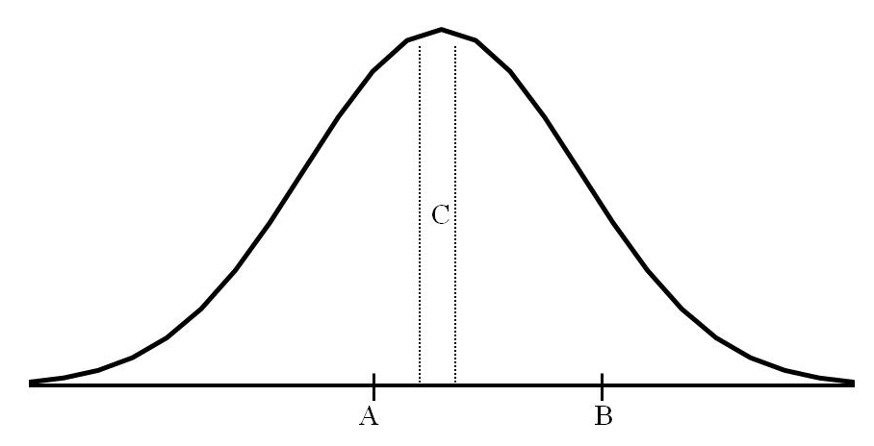
- Left-Right dimension
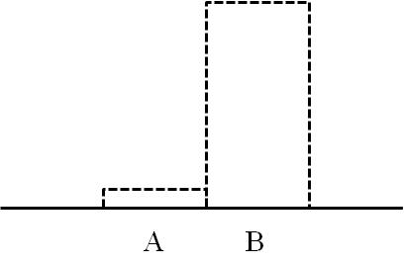
- Valence issue “owned” by B (for example “economic competence”).

Top figure shows that party A is closer to the centre of the left-right axis than party B. Party A thus has higher chances to win the key centre voter and therefore to win the elections. According to the standard spatial model, party B should compete by moving its policy manifesto towards the centre. However, as (Adams, Ezrow, and Somer‐Topcu 2011) implicitly suggest, redesigning its ideological orientations and move the party towards the centre is not an easy task. If party B changes its policy positions but voters do not believe it, the mean voter will still vote for party A. Party B is a “permanent loser” in the left-right dimension. However, using valence considerations, party B is able to compete on an issue in which it has an electoral advantage (bottom figure). Following an heresthetical strategy, party B will try to emphasise the importance of that valence issue, in which it has an advantage, among the electorate. Finally, according to our proposal, party A will not remain with arms folded. Party A will do its best to maintain or even increase the salience among the electorate of the left-right dimension. Thus, depending of what party wins in their “marketing” effort, the Left-right dimension or valence issues will more important in the elections.
In sum, for us ideological convergence is not a condition for the 'permanent loser' on the ideological dimension to undertake a valence strategy if it wants to increase its chances to win the elections. By competing on valence issues, the 'permanent loser' tries to overcome its difficult situation on the ideological dimension and have an electoral advantage. And by competing on the Left-right dimension, the “permanent winner” tries to maintain its electoral advantage.
Finally we also take into consideration the first criticisms of Downs’ voting model. This strategy is expected to affect all the electorate, but we would expect its impact will be higher on the centre. Our argument is based on the heuristics logic: even though the 'permanent loser' on the ideological dimension would desire that all the electorate took into account only valence considerations, party cues will have a strong effect on those with a party of reference.
Party Identification (PID) among left and right-wing voters is usually stronger, so parties will offer cues to voters on what they eventually think about political issues. Therefore, when the party 'loser' on left-right terms tries to introduce a valence issue, the opposite party will campaign to emphasise the left-right differences between itself and the opposition. This political struggle will be channelled through PID and hence will align voters with its party on a particular issue. However, in the case of the centre position, parties will be more prone to convince this part of the electorate as its weaker PID will not conduct them to be automatically aligned with the opposite party. Targeting centre voters is easier as their party identification is weaker and they usually swing from one party to another depending on the election. Since the median voter tends to stand on this position, the centre will be of particular importance for both the 'permanent loser' and the party closer to it on the left-right dimension. The difference relies on the strategy to obtain their support: whereas the party closer to the centre will emphasise Left-Right positional issues, the 'permanent loser' will campaign on valence considerations.

Hypotheses
According to the Clarke (2004), Green (2007) and Green and Hobolt (2008) model detailed in the previous section, parties only compete on valence dimensions when they take very similar positions on the left-right dimension. We have argued that valence competition may also be important when a party is a 'loser' on the ideological dimension. Thus, the disadvantageous party on the ideological dimension will be able to win when valence issues appear as important. This argument leads us to consider the first hypothesis.
H1: The proximity component of the utility calculus is less important than valence evaluations concerns to vote decisions when the loser' wins the elections.
The reverse mechanism is also expected: when the party closer to the median voter wins, the electorate has given priority to the ideological distance.
In the proximity model, a voter's utility on each dimension for party p is a declining function of the policy distance from voter to candidate (Downs 1957; Enelow and Hinich 1984). Giving that it has an advantage, a party closer to the median voter will try to emphasise the importance of this distance, whereas party away from the centre will stress the importance of valence issues' evaluations. Since both parties will try to emphasise the dimension in which they have an advantage, we expect that both ideological distance and valence evaluation play a role depending on the political side. This political struggle yields us with the second bulk of hypotheses.
H2: When parties diverge ideologically, ideological distance will be more strongly associated with vote choice for the supporters of the party closer to the centre.
H3: When parties diverge ideologically, valence considerations will be more strongly associated with vote choice for the supporters of the 'permanent loser' on the ideological dimension.
We have argued that party cues shape citizens preferences and thus affect how party strategies are perceived by voters. At the same time, we sustained before that these strategies affect differently those on the centre that voters with a leftist and rightist ideology because valence issues will not be channelled through partisanship. This argument leaves us with the following hypotheses.
H4: Valence issues will have a greater impact on vote choice on the centre of the ideological spectrum than on the rest when the ‘permanent loser’ on the ideological dimension wins the elections.

The Spanish ‘permanent’ loser
To sum up our argument, if a given party is a loser and can expect to stay in that situation, it may prefer to challenge the existing party competition terms. In contrast, if the opposite party has reasonable expectations of gaining power within the existing political framework, it will try to maintain the status quo.
The Spanish party system fits almost perfectly this scenario. Almost bipartisan in nature, the Socialist Party (PSOE) occupies the leftist part of the political spectrum and the conservative Popular Party (PP) is the main party on the right. Since the socialist victory in 1982, PSOE has been in power 21 years, in which 52.4% of them it had an absolute majority in the Parliament.
The ideological distribution of the Spanish electorate is shifted to the left, being the leftist positions (1-4 on the ideological axis) the most important in quantitative terms.

Figure 2: Ideological distribution of the Spanish electorate (1989-2008)
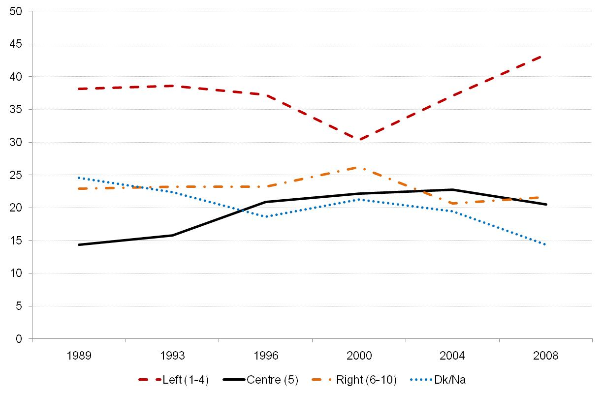
Source: CIS post-election surveys.

The Spanish conservative party is located far away from the centrist position, further than most of the opposition parties in Europe. In comparative perspective, it is one of the parties located further from the median point of the ideological scale. The following table illustrates this phenomenon. It shows the distance between the median voter and the main party on the right and on the left in different countries. Apart from the Swedish Moderate Party, the Spanish Popular Party is consistently located away from the median point and this situation has not changed over time.

Table 1 Absolute distance between the 'conservative party' and the median voter in different European countries
Country | Year | Party | Distance | Most voted? | % votes | Left/Right
Sweden | 2002 | Moderate Party | 4.16 | No | 15.3% | R
Sweden | 1979 | Moderate party | 3.98 | No | 20.3% | R
Sweden | 1982 | Moderate party | 3.93 | No | 23.6% | R
Sweden | 1988 | Moderate party | 3.87 | No | 18.3% | R
Sweden | 1994 | Moderate party | 3.84 | No | 22.4% | R
Sweden | 1985 | Moderate party | 3.8 | No | 21.3% | R
Sweden | 1998 | Moderate party | 3.76 | No | 22.9% | R
Spain | 1989 | PP Popular Party | 3.44 | No | 25.8% | R
Norway | 1993 | Conservative Party | 3.32 | No | 17% | R
Sweden | 2006 | Moderate Party | 3.26 | No | 26,2% | R
Sweden | 1991 | Moderate party | 3.25 | No | 21.9% | R
Spain | 1996 | PP Popular Party | 3.23 | Yes | 38.8% | R
Netherlands | 1972 | PVDA | 3.23 | Yes | 27.3% | L
Spain | 2008 | PP Popular Party | 3.18 | No | 39.9% | R
Spain | 1993 | PP Popular Party | 3.18 | No | 34.8% | R
Spain | 2004 | PP Popular Party | 3.12 | No | 37.7% | R
Norway | 1985 | Conservative Party | 2.99 | No | 30.4% | R
France | 2007 | Sarkozy | 2.98 | Yes | 31.2% | R
Netherlands | 1986 | PVDA | 2.84 | No | 33.3% | L
Germany | 1976 | SPD | 2.82 | No | 43.7% | L
Netherlands | 1981 | PVDA | 2.76 | No | 28.3% | L
Italy | 2006 | Casa della Libertà | 2.65 | No | 49.7% | R
Norway | 1989 | Conservative Party | 2.65 | No | 22.2% | R
Spain | 2000 | PP Popular Party | 2.52 | Yes | 44.5% | R
Sources: Europen Voter, Enquête post-électorale française 2002, Panel Electoral Français 2007, Italian National Election Study 2006, encuestas postelectorales España 1989, 1996, 2008, 1993, 2004, 2000.

Second, not only in comparative perspective PP is one of the conservative parties further away from the mean voter. The Spanish electorate considers this party as right-wing and far away from the centre ground, where the majority stands. Figure 3 shows this evidence. Graph A illustrates the mean party placement scores of the socialists (dot line) and the conservatives (dash line). Solid line indicates the evolution of the position of the mean voter. PP has always been far from the centre. Those on the centre of the ideological scale also locate the Spanish conservative party further than its rival (B). This tendency has not changed over time. In fact, those voters that locate themselves on the centre of the scale, have always located the socialists closer to them than the PP.

Figure 3: Ideological placement of PSOE and PP according to the electorate and the median voter (1989-2008)
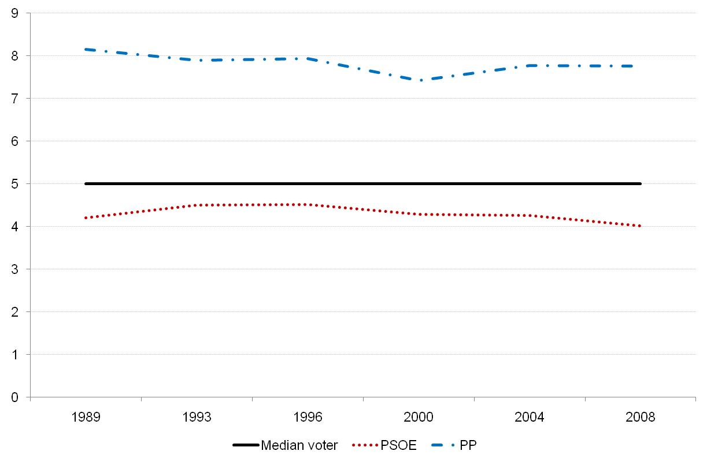
- General electorate

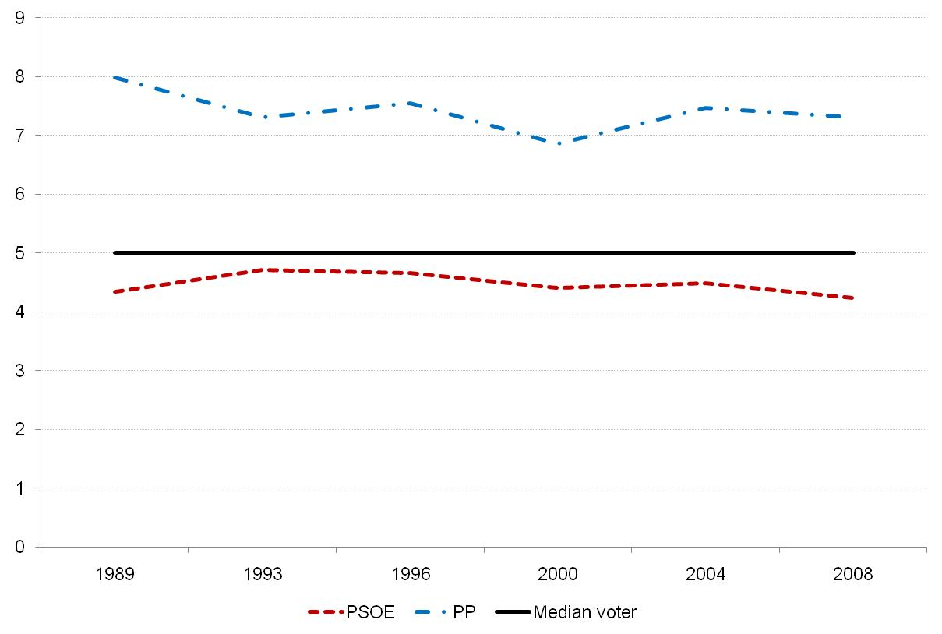
- Median voter

This ideological distribution is a priori damaging the electoral possibilities of the conservative party. However, even if the centrist voter has always located the PP further away from them than the PSOE, in several occasions most centrist voters chose the PP. The following figure illustrates the vote choice among centre voters. It shows than in 1996 and in 2000, when PP won the elections, most centrist voters opted for this party.

Figure 4: Vote choice among centre voters and the party that was in government during the period (1989-2008)
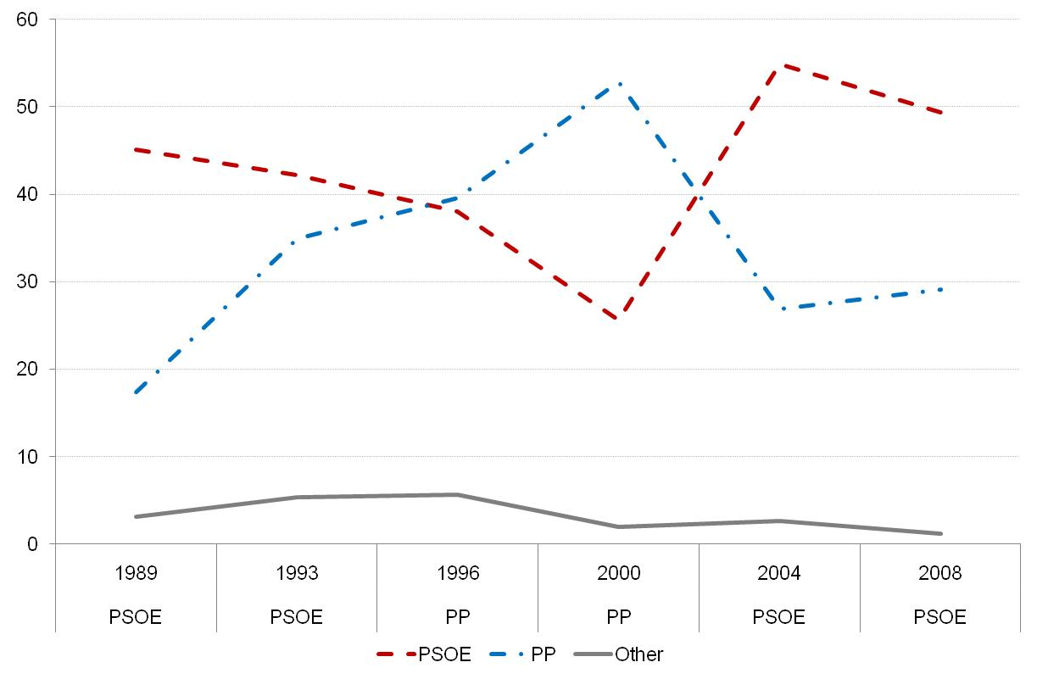
Sources: post-election surveys (CIS).

Research Strategy
In order to evaluate our propositions we employ the pre-election surveys in the run-up to the 2000 and 2008 Spanish elections. We study these elections for several reasons: First, both surveys have equivalent measures in order to capture ideological distances and valence evaluations. Second, before the 2000 elections the PP was in power without an absolute majority in the Parliament and having completed the first four years in government since the restoration of the Spanish democracy. Before the 2008 elections the PSOE was in power –also without and absolute majority in the Parliament- and had been governing since it won the 2004 elections. Third, both in 2000 and 2008 the economic situation were similar. The GDP grew around 4% in both periods and the country had experienced a long period of economic growth.
In order to ease interpretation, our dependent variable is vote choice coded 0 = vote for the opposition and 1 = vote for the incumbent. Since our dependent variable has two options, a logistic model is employed. The logit coefficients obtained from this model do not have a straightforward interpretation -it is only possible to comment on the direction and the statistical significance of the effects-, so we will mainly interpret the marginal effects of the different variables of interest (King, Tomz, and Jason Wittenberg 2000).
Ideological proximity is measured as the quadratic distance between the voter's position and party position on the left-right scale (where 1 represents extreme left and 10 extreme right). Voter's utility represents a declining function of policy distance from voter to party (Downs 1957; Enelow and Hinich 1984) and is defined as follows:

U_{ip} = - (P_{p} – P_{i})² (1)

where voter i's overall evaluation of party p's utility depends upon the squared distance between a party's position (Pp) and the voter's i's own preferred position or ideal point. We calculate the distance to the main two parties (PSOE and PP).
We mainly consider four valence dimensions. First, evaluation of how the party in government has managed the economy (Whiteley 1984). This variable ranges from 1 (very bad opinion of party in government's handling of economic policies) to 5 (very good opinion). Second, following recent research (Groseclose 2001; Clarke et al. 2004; Schofield 2004) we also include leadership ratings. We include a scale that evaluates what José María Aznar (in 2000) and José Luís Rodríguez Zapatero (in 2008) have done in government. It ranges from 0 (very bad opinion) to 10 (very good opinion). Third, we include a salient issue in Spanish politics both in 2000 and 2008 that is considered as valence: the Spanish territorial model. This variable assesses how the party in government has handled the territorial issues and ranges from 1 (very bad opinion) to 5 (very good opinion). Finally, we also include a variable tackling another relevant issue in Spanish politics: how the government has handled terrorism policies (like the last one, it also ranges from 1 to 5) .
In order to see that valence dimensions affect more strongly the centre than the rest, we include a dummy variable than distinguishes those that locate themselves on the centre (1) than the rest (0). We exclude those that do not know or not reveal their ideological position.
Each model also controls for age, sex (1= Men, 0 = Women) and education (0 = No education, 1 = Primary education, 2 = Secondary, 3 = Professional Formation, 4 = University and postgraduates). Results are displayed in Figure 4.

Table 2: Logistic model for 2000 and 2008 elections
 | 2000 | 2008
 | b/se | b/se
Opinion on government’s handling of the economy | 0.78*** | 0.60***
 | (0.07) | (0.08)
Leadership rating  (Aznar and Zapatero) | 0.79*** | 0.79***
 | (0.03) | (0.04)
Opinion on government’s handling of the territorial model | 0.41*** | 0.34***
 | (0.06) | (0.08)
Opinion on government’s handling of terrorism | 0.30*** | 0.52***
 | (0.05) | (0.07)
Centre location  (1=centre; 0=L/R) | 0.11 | 0.19
 | (0.10) | (0.12)
Quadratic distance to PSOE | -0.09*** | 0.53***
 | (0.01) | (0.04)
Quadratic distance to PP | 0.12*** | -0.79***
 | (0.01) | (0.04)
Age | -0.00 | -0.00
 | (0.00) | (0.00)
Gender (female) | -0.07 | -0.21
 | (0.10) | (0.12)
Education | 0.19*** | 0.00
 | (0.04) | (0.05)
Constant | -8.79*** | -9.07***
 | (0.38) | (0.44)
Pseudo R-Squared | 0.707 | 0.771
Prob > chi2 | 0.00 | 0.00
Log likelihood | -1530.85 | -1530.85
Obs. | 7846 | 6592

In order to ease interpretation and offer interpretable results, we present the marginal effects of ideological proximity and the four valence dimensions (assessment of the handling of the economy, the territorial model and terrorism and the leadership ratings) on the probability of voting PP and PSOE in each election, holding all other variables to their mean (King, Tomz, and Jason Wittenberg 2000). In order to make these measures comparable across surveys, we follow Green and Hobolt (2008) approach and we measure the marginal effect (first difference) by increasing the proximity and the valence measures one standard deviation from the mean. We then calculate the change in the probability of voting for each party. Following our theoretical expectations, we calculate the probability for the population in general and for those located on the centre of the ideological scale.
The first differences displayed in Table 3 demonstrate a very substantial change in the impact of ideology and valence dimensions on 2000 and 2008 elections. In 2000 -when PP won the elections-, the marginal effect of a standard deviation change in the leadership rating increases 0.27 among the centre voters and 0.25 among the general population. At the same time, a better assessment of the handling of the economy increases the likelihood to support the conservative party by 0.19 points (0.18 among centrist). Conversely, having a good opinion on how the PP has handled the territorial model hardly increases the probability of voting for this party (0.06). The effect of the opinion on the handling of the territorial model is also low (0.05).
H1 stated that the proximity component of the utility calculus will be less important than valence issues when the ‘loser’ on the ideological dimension wins the elections. Among the four valence dimensions included in the analysis, two of them (economy and leadership ratings) have a considerable impact on the likelihood of voting the incumbent party, which in turn is a clear ‘loser’ on the ideological dimension. These results confirm our theoretical expectations in H1: in 2000 the Spanish conservative party -the ‘loser’ on the ideological dimension- was able to surpass this difficulty and take profit of its valence advantage, especially through its leadership ratings and the handling of the economy.
This process took place in a situation of non-convergence. In this scenario, and even though results showed that party competition was fought on the basis of valence considerations, we hypothesised in H2 that still the ‘winner’ will emphasise its proximity component. Results showed the marginal effect of the ideological proximity to PSOE is very low, indicating that this party was not able to emphasise its advantage on the ideological dimension.
Finally, the marginal effect of valence dimensions among centre voters is not higher than among the general population (H4). Only in the case of leadership ratings centre voters seem more affected, although confidence intervals overlap. Therefore, we cannot accept H4.

Table 3: Change in marginal effect of different valence indicators and left-right distance upon incumbent vote choice in 2000 including confidence intervals
 |  | Mean + 1σ | 95% confidence intervals
Economy | Population | 0.19 | 0.16 | 0.22
 | Centre voters | 0.18 | 0.15 | 0.21
Leadership | Population | 0.25 | 0.23 | 0.26
 | Centre voters | 0.27 | 0.25 | 0.30
Territorial model | Population | 0.06 | 0.04 | 0.08
 | Centre voters | 0.06 | 0.04 | 0.07
Terrorism | Population | 0.05 | 0.03 | 0.07
 | Centre voters | 0.05 | 0.03 | 0.07
Distance PP | Population | 0.03 | 0.02 | 0.04
 | Centre voters | 0.09 | 0.08 | 0.10
Distance PSOE | Population | -0.10 | -0.12 | -0.09
 | Centre voters | -0.10 | -0.11 | -0.09

Table 4 shows a different story. In 2008 PSOE won the elections and it did so because it was able to stress its ideological advantage. Whereas in 2000 the marginal effect of the ideological proximity between voters and the socialists was almost negligible (0.10), in 2008 the effect of the ideological proximity is significantly higher. The reported marginal effect of a standard deviation change in the ideological proximity between voters and the socialists equals 0.43 for the general population, 0.79 among centrist voters. Leadership still has a significant impact on the likelihood of voting the socialists, whereas the assessment of the handling of the economy and the territorial model do not importantly increase the likelihood of voting them. In 2008 differences with the centre voters arise: leadership impact is lower on the centre than on the rest (0.17 versus 0.20) and is significantly higher on the case of the ideological proximity to the Socialists.
Results show that in 2008 proximity was also important for voting PP (the marginal effect is 0.78, 0.42 among centre voters), an evidence rationally difficult for PP considering its disadvantage situation on the left-right dimension.

Table 4: Change in marginal effect of different valence indicators and left-right distance upon incumbent vote choice in 2008 including confidence intervals
 |  | Mean + 1σ | 95% confidence intervals
Economy | Population | 0.07 | 0.05 | 0.09
 | Centre voters | 0.07 | 0.05 | 0.09
Leadership | Population | 0.20 | 0.17 | 0.21
 | Centre voters | 0.17 | 0.14 | 0.20
Territorial model | Population | 0.04 | 0.02 | 0.06
 | Centre voters | 0.04 | 0.02 | 0.06
Terrorism | Population | 0.07 | 0.05 | 0.09
 | Centre voters | 0.07 | 0.05 | 0.08
Distance PP | Population | -0.78 | -0.81 | -0.73
 | Centre voters | -0.42 | -0.46 | -0.39
Distance PSOE | Population | 0.43 | 0.39 | 0.46
 | Centre voters | 0.79 | 0.73 | 0.82

Both tables indicate that our expectations put forward in H2 and H3 were partially confirmed. Even though we thought that the valence or the positional component will predominate, we hypothesised that the distance to the party will be also important for the supporters of the ‘winner’ on the ideological dimension, whereas supporters of the ‘loser’ on the ideological dimension will give more importance to valence considerations. Results indicate that this process depends upon the party that wins the elections. In 2000, when the ‘permanent loser’ won the elections, valence considerations were more important, even for supporters of the ‘winner’. Conversely, in 2008, when the ‘winner’ enforced its advantageous situation on the left-right dimension, ideological distance became salient, even for the opponent. At the same time, contrary to what we expected, we do not see any difference on the impact of valence issues on the centre and the rest. We however found that the distance component in 2008 is more important when voting PSOE for centrist voters than for the general population.

Conclusions
Kenneth A. Shepsle (2003, 312) once stated: “not enough attention is given to losers. We teach and write political history by focusing on the winners. Indeed, it is often alleged that the winners themselves actually write the history, thereby underemphasising the significant role played by losers”. This article has been an attempt to understand how party ‘losers’ on the overwhelming left-right dimension are able to change party competition and compete on a dimension in which they have an advantage.
That is: in this research we have followed Riker’s considerations that persistent losers always have incentives to repackage the issues in order to “divide the majority with a new alternative, one that he [a person who expect to lose on some decision] prefers to the alternative previously expected to win”. In other words, a loser tries to figure out a way to become a winner.
Contrary to the conventional wisdom, we have integrated different theoretical perspectives and we have argued that when parties have not converged, proximity logic is not a fortiori expected. Political parties will compete emphasising the aspect in which they have an advantage: whereas the ‘winner’ on the ideological dimension will try to emphasise its ideological advantage, the ‘loser’ will try to raise valence issues advantageous for its electoral prospects.
Spain has been used as a model to test our hypothesis. The Spanish party system has not followed a centripetal pattern and it is a good example to illustrate the dynamics in which party ‘losers’ and ‘winners’ are engaged. Studying 2000 and 2008 elections –with different parties in power- we have shown that valence dimensions also matter in a non-centripetal system. At the same time, we have demonstrated that ideological distance matters more when the party closer to the median voter wins, whereas valence configurations are more important when the ‘permanent loser’ wins the elections.
Therefore, the proximity component of the utility calculus is less important than valence evaluations concerns to vote decisions when the 'permanent loser' wins the elections. And, contrary to what we have hypothesised, this mechanism works for supporters of both parties. If valence dimensions are more important in party competition in a given election, it seems that their importance is perceived by the supporters of the ‘permanent loser’ as well as by the supporters of the ‘winner’.
Macdonald and Rabinowitz (1998) pointed out that “one of the paradoxes of democratic politics is that in two-party electoral systems parties do not usually converge”, although standard theories of party competition suggest they will. In this paper we do not reject that median voter creates convergence. We rather argue that, in a situation of non-convergence, you can attract centre voters without a non-centripetal movement.

References
Abney, Ronni, James Adams, Michael Clark, Malcolm Easton, Lawrence Ezrow, Spyros Kosmidis, and Anja Neundorf. 2011. «When does valence matter? Heightened valence effects for governing parties during election campaigns». Party Politics 17 (5).
Adams, James, Michael Clark, Lawrence Ezrow, and Garrett Glasgow. 2004. «Understanding Change and Stability in Party Ideologies: Do Parties Respond to Public Opinion or to Past Election Results?» British Journal of Political Science 34 (04): 589-610.
Adams, James, Lawrence Ezrow, and Zeynep Somer‐Topcu. 2011. «Is Anybody Listening? Evidence That Voters Do Not Respond to European Parties’ Policy Statements During Elections». American Journal of Political Science 55 (2) (April 1): 370-382.
Bara, Judith L. 2006. «The 2005 Manifestos: A Sense of Déjà Vu?» Journal of Elections, Public Opinion & Parties 16 (3): 265-281.
Bara, Judith, and Ian Budge. 2001. «Party Policy and Ideology: Still New Labour?» Parliamentary Affairs 54 (4): 590 -606.
Bélanger, Éric, and Bonnie M. Meguid. 2008. «Issue salience, issue ownership, and issue-based vote choice». Electoral Studies 27 (3): 477-491.
Berelson, Bernard R., Paul F. Lazarsfeld, and William N. McPhee. 1954. Voting: A Study of Opinion Formation in a Presidential Campaign. Chicago: University Of Chicago Press.
Blomqvist, Paula, and Christoffer Green-Pedersen. 2004. «Defeat at Home? Issue‐Ownership and Social Democratic Support in Scandinavia». Government and Opposition 39 (4): 587-613.
Budge, Ian, and Dennis J. Farlie. 1983. Explaining and Predicting Elections: Issue Effects and Party Strategies in Twenty-Three Democracies. Unwin Hyman.
Budge, Ian, Hans-Dieter Klinge, Andrea Vokens, Judith Bara, and Eric Tanenbaum. 2011. Mapping Policy Preferences: Estimates for Parties, Electors and Governments, 1945-1998. Oxford: Oxford University Press.
Budge, Ian, David Robertson, and Derek Hearl. 1987. Ideology, Strategy and party change. Spatial analysis of post-war election programmes in 19 democracies. Cambridge: Cambridge University Press.
De la Calle, Luis, Álvaro Martínez, and Lluís Orriols. 2010. «Voting without ideology. Evidence from Spain (1979-2008)». Revista Española de Investigaciones Sociológicas (129): 107-129.
Camia, Valeria, and Daniele Caramani. 2011. «Family meetings: Ideological convergence within party families across Europe, 1945–2009». Comparative European Politics.
Campbell, Angus. 1960. The American voter. Chicago: University of Chicago Press.
Clarke, Harold D., David Sanders, Marianne C. Stewart, and Paul Whiteley. 2004. Political Choice in Britain. OUP Oxford.
Cox, Gary W. 1990. «Centripetal and Centrifugal Incentives in Electoral Systems». American Journal of Political Science 34 (4): 903-935.
Curtice, John. 2005. «Turnout: Electors Stay Home—Again». Parliamentary Affairs 58 (4): 776 -785.
Dalton, Russell J., Scott C. Flanagan, and Paul Allen Beck. 1984. Electoral Change in Advanced Industrial Democracies: Realignment or Dealignment? Princeton University Press.
Downs, Anthony. 1957. An Economic Theory of Democracy. Harper.
Eijk, Cees van der. 2005. Left-Right Orientations and Party Choice. In The European voter: a comparative study of modern democracies, ed. Jacques Thomassen, 166-190. Oxford: Oxford University Press.
Enelow, James M., and Melvin J. Hinich. 1984. The Spatial Theory of Voting: An Introduction. Cambridge University Press.
Evans, Geoffrey. 1998. «Euroscepticism and Conservative Electoral Support: How an Asset Became a Liability». British Journal of Political Science 28 (4): 573-590.
Ezrow, Lawrence. 2010. Linking citizens and parties: how electoral systems matter for political representation. Oxford University Press.
Franklin, Mark N., Thomas T. Mackie, and Henry Valen. 1992. Electoral Change: Responses to Evolving Social and Attitudinal Structures in Western Countries. Cambridge University Press.
Frode, Berglund, Sören Holmberg, Hermann Schmitt, and Jacques Thomassen. 2005. Party Identification and Party Choice. In The European voter: a comparative study of modern democracies, ed. Jacques Thomassen. Oxford: Oxford University Press.
Fuchs, Dieter, and Hans D Klingemann. 1990. Continuities in Political Action: A Longitudinal Study of Political Orientations inThree Western Democracies. In , ed. Kent Jennings and J.W. Van Deth. Berlin: Walter de Gruyter.
Green, Jane. 2007. «When Voters and Parties Agree: Valence Issues and Party Competition». Political Studies 55 (3): 629-655.
Green, Jane, and Sara B. Hobolt. 2008. «Owning the issue agenda: Party strategies and vote choices in British elections». Electoral Studies 27 (3): 460-476.
Green-Pedersen, Christoffer, and Peter B Mortensen. 2010. «Who sets the agenda and who responds to it in the Danish parliament? A new model of issue competition and agenda‐setting». European Journal of Political Research 49 (2): 257-281.
Groseclose, Tim. 2001. «A Model of Candidate Location When One Candidate Has a Valence Advantage». American Journal of Political Science 45 (4): 862-886.
Hinich, Melvin J., and Michael C. Munger. 1994. Ideology and the Theory of Political Choice. 1st ed. University of Michigan Press.
Inglehart, Ronald, and Hans-Dieter Klingemann. 1976. Party Identification, Ideological Preference and the Left-Right Dimension among Western Mass Publics. In Party Identification and Beyond, ed. Ian Budge, Ivor Crewe, and Dennis Farley. London: New York Wiley.
Kinder, Donald R., and Shanto Iyengar. 1989. News That Matters: Television and American Opinion. University of Chicago Press.
King, Gary, Michael Tomz, and Jason Wittenberg. 2000. «Making the Most of Statistical Analyses: Improving Interpretation and Presentation». American Journal of Political Science 44 (2): 347-361.
Kitschelt, Herbert, and Staf Hellemans. 1990. «The Left-Right Semantics and the New Politics Cleavage». Comparative Political Studies 23 (2): 210 -238.
Knight, Kathleen. 1985. «Ideology in the 1980 Election: Ideological Sophistication Does Matter». The Journal of Politics 47 (3): 828-853.
Knutsen, Oddbjørn. 1997. «The Partisan and the Value-based Component of Left-Right Self-placement: A Comparative Study». International Political Science Review 18 (2): 191 -225.
Lago, Ignacio, and José Ramon Montero. 2005. «Del 11-M al 14-M: los mecanismos del cambio electoral». Claves de la Razón Práctica.
Laver, Michael, Kenneth Benoit, and John Garry. 2003. «Extracting Policy Positions from Political Texts Using Words as Data». American Political Science Review 97 (02): 311-331.
Lenz, Gabriel S. 2009. «Learning and Opinion Change, Not Priming: Reconsidering the Priming Hypothesis». American Journal of Political Science 53 (4): 821-837.
Macdonald, Stuart Elaine, and George Rabinowitz. 1998. «Solving the paradox of nonconvergence: valence, position, and direction in democratic politics». Electoral Studies 17 (3): 281-300.
Maravall, José María. 2008. La confrontación política. Madrid: Taurus.
Merrill, Samuel, and Bernard Grofman. 1999. A unified theory of voting: directional and proximity spatial models. Cambridge University Press.
Petrocik, John R. 1996. «Issue Ownership in Presidential Elections, with a 1980 Case Study». American Journal of Political Science 40 (3): 825-850.
Petrocik, John R., William L. Benoit, and Glenn J. Hansen. 2003. «Issue Ownership and Presidential Campaigning, 1952-2000». Political Science Quarterly 118 (4): 599-626.
Popkin, Samuel L. 1994. The Reasoning Voter: Communication and Persuasion in Presidential Campaigns. 1st ed. University Of Chicago Press.
Rabinowitz, George, and Stuart Elaine Macdonald. 1989. «A Directional Theory of Issue Voting». The American Political Science Review 83 (1): 93-121.
Ramiro-Fernandez, Luis. 2005. «Programmatic Adaptation and Organizational Centralization in the AP-PP». South European Society and Politics 10 (2): 207-223.
Riker, Professor William H. 1986. The Art of Political Manipulation. Yale University Press.
Schofield, Norman. 2003. «Valence Competition in the Spatial Stochastic Model». Journal of Theoretical Politics 15 (4): 371 -383.
———. 2004. «Equilibrium in the Spatial ‘Valence’ Model of Politics». Journal of Theoretical Politics 16 (4): 447 -481.
Schofield, Norman, and Itai Sened. 2005. «Modeling the interaction of parties, activists and voters: Why is the political center so empty?» European Journal of Political Research 44 (3): 355-390.
Shepsle, Kenneth A. 2003. «Losers in Politics (And How They Sometimes Become Winners): William Riker’s Heresthetic». Perspectives on Politics 1 (2): 307-315.
Simon, Adam F. 2002. The Winning Message: Candidate Behavior, Campaign Discourse, and Democracy. Cambridge University Press.
Stokes, Donald E. 1963. «Spatial Models of Party Competition». The American Political Science Review 57 (2): 368-377.
Thomas, John. 1980. «Policy Convergence among Political Parties and Societies in Developed Nations: A Synthesis and Partial Testing of Two Theories». The Western Political Quarterly 33 (2): 233-246.
Whiteley, Paul. 1984. «Perceptions of economic performance and voting behavior in the 1983 general election in Britain». Political Behavior 6 (4): 395-410.

Valence issues are those issues were both voters and parties agree on the same goals, even though the means that achieve them may be different. We further discuss this definition in the theoretical section.
There are some caveats to be taken into consideration regarding the validity of this statement: the implications of centripetal and centrifugal incentives differ when the electoral system (and some features of the institutional design) is taken into account (Cox 1990). However, as we analyse the same country with the same electoral system, these considerations are taken aside.
In addition, studies based on representative surveys, on expert judgments and content analysis of party manifestos (Inglehart and Hans-Dieter Klingemann 1976; Laver, Kenneth Benoit, and Garry 2003; Budge et al. 2011), found that one’s ideological orientation plays a key role in explaining the process through which citizens evaluate, and choose, among competing candidates and parties.
Here we do not refer to the conception of political conflict is always unidimensional, but the very “nature” of the issue parties compete on. Stokes underlined that “although the assumption of unidimensionality is a familiar part of prevailing spatial conceptions of party competition, it might well be dispensed with. Hotelling’s original argument can easily be generalised into two dimensions, as Hotelling himself observed (Stokes 1963, 371).
According to Petrocik (1996), a candidate “owns” an issue when citizens consider that he is better able to “handle” that issue than his opponent. Petrocik also considers that a candidate who owns an issue will consequently wage a campaign to increase the salience of that issue, and “in doing so, cause voters to use their party linked perception of the issue handling ability of the candidates to choose between (or among) them” (p.827).
Heresthetics is understood as the framing of a debate or issue so that one is on the superior or winning side (Riker 1986).
Apart from what is referred as the “dominance principle” stated by Riker, there are various incarnations of this approach, mainly the ‘salience theory’ (Budge and Farlie 1983) or the 'issue ownership theory' (Petrocik 1996; Petrocik, William L. Benoit, and Hansen 2003). It is also important to point out that owning an issue does not guarantee an immediate electoral success (Evans 1998).
Acording to Shepsle (2003), a “political loser” is not only an out-of-power politician but also a politician that maintains an “out-of-favour political position” in a salient dimension. If he is not able to convince the public that he has changed his position in that dimension, we call him a “permanent loser”. But, as said, a “permanent loser” in any given dimension can win the elections if he convinces the public the salient issue in politics is the he “owns”.
This literature is based on a line of thought that argue that parties are increasingly equal on the left-right dimension (Thomas 1980; Budge, Robertson, and Hearl 1987; Kitschelt and Hellemans 1990; Camia and Caramani 2011).
The first scenario shows an asymmetrical polarisation process. We can indeed think about other polarisation dynamics, such as a symmetrical one (Downs 1957). However, this is empirically rare in bipartisan contexts, although it will be an interesting avenue for future research in multi-party competition.
Heuristics are described as problem-solving strategies that help people to make up their mind about political issues and finally to come to a voting decisions (Fuchs and Hans D Klingemann 1990; Hinich and Munger 1994; Knight 1985; Popkin 1994).
There is another leftist party, Izquierda Unida (IU), which is on the left of the socialists, with 2 seats. Furthermore, in 2008 a new party, Unión Progreso y Democracia (UpyD) also entered the Parliament with 1 seat. Although the impact of these parties is not negligible, the two main parties concentrate most of the popular votes (83.81% of the votes in 2008). Together, since 1986, they have occupied more than 70% of the seats in the Parliament. Therefore, we will focus our attention on the impact of the two main parties as the inclusion of these two parties do not change substantively our results, as well as we do not have enough cases included in the surveys.
Even though the left is more numerous, a coalition between the centre and the right will still defeat it. This leaves the Spanish case close to distribution outlined in
We took the main party on the right and the main on the left and we calculated the distance to the median voter. We only show the parties that are further from the median point (n=162).
In spite of moving its policy platform towards the centre (Ramiro-Fernandez 2005), the Spanish electorate has always located the PP far away from the centre. At the same time, this figures shows a different tendency than the convergence between the main parties occurred in the United Kingdom (Green and Hobolt 2008). In fact, the UK is one of the few countries where a convergence between the main parties has been perceived by the general population (Adams, Ezrow, and Somer-Topcu 2011; Budge et al. 2011)
According to Maravall (2008, 26), “si la competición hubiera tenido lugar en una sóla dimensión y ésta hubiera sido la ideológica, éste hubiera ganado siempre”.
Maravall (2008) argues that this anomaly is due to the use of negative campaigns. Allegedly, these campaigns are able to demobilise your rivals’ voters. However, firstly, this argument is still a debate in the literature. In fact, Maravall considered that PP undertook a negative campaign between 93-96 and 2004-2008 and in both periods participation increased. Not only that, but in 2000 and 2006, without a negative campaign scenario, participation declined. Secondly, even if Maragall was right, still this does not explain the centrist preference for the Popular Party.
Both surveys are freely available at the Centro de Investigaciones Sociológicas website (www.cis.es). We cannot use post-election surveys as they do not include the questions that we need for our analysis.
We could also have chosen the 2004 elections. However, this contest was surrounded by special events –that is, the terrorist attack in Madrid and how the government managed the situation- that can confound our findings (for more information see (Lago and Montero 2005)).
Recall that in 2000 the incumbent was PP and the Socialists were in power in 2008.
Tomz, Michael, Jason Wittenberg, and Gary King. CLARIFY: Software for Interpreting and Presenting Statistical Results In Journal of Statistical Software. Vol. 8., 2003. copy at http://j.mp/k3k0rx
Including both measures in the same model might be problematic. Distance to these parties may represent two sides of the same coin. Voters tend to move the opposite party away from its position (Merrill and Grofman 1999), possibly creating a correlation between two proximity measures. However, it does not seem the case in our analysis. The correlation between the PP and PSOE quadratic distance equals -0.004 (2000) and -0.23 (2008).
If instead of the evaluation of the management of the economy by the party in government we include the opinion on the general state of the economy, results still hold (available upon request).
We exclude those that do not have an opinion.
To see how the Spanish conservative party exploits both issue see Maravall (2008).
In their research about British politics, Hobolt and Green (2008) include handling ability variables on different topics and the importance attach to each issue by voters. Unfortunately the pre-election surveys did not include these questions.
Furthermore, it has already been stated that those without ideology have a higher probability to vote for the incumbent party (De la Calle, Martínez, and Orriols 2010).

